Nushagak Chinook Salmon S/R Analysis

Internal ADF&G Memo

During the 2018 Escapement goal review cycle, we discovered that there was a discrepancy between the brood tables used to generate the 2012 escapement goal and the established brood tables being used by ADF&G. We were eventually able to determine that the 2012 escapement goal was developed using incorrect brood tables where productivity was biased high as a result of mistakenly applying a correction factor to harvest (Erickson et al. 2018, Figure 1). Interestingly enough, the correct brood tables and the incorrect escapement goal were both published in March of 2012. What we are calling the correct brood tables were published by Buck et al. (2012) (Appendix B6), and the incorrect S/R analysis can be found in Fair et al. (2012) (Appendix A6). During this spawner recruit analysis, we will again fully run the incorrect dataset (Appendix A) for comparison purposes with the correct dataset (Appendix B) to determine if it would have changed the escapement goal that was established in 2012.

Figure 1: Comparison of productivity in recruits per spawner by brood year between the established Bendix/DIDSON conversion (Buck et al. 2012) and the incorrect dataset used in the 2012 escapement goal review (Fair et al. 2012).

In order to incorporate the two most recent tagging studies and all available historical data, the department has developed a run reconstruction model for Nushagak Chinook salmon (Head and Hamazaki, in prep). In order to compare the spawner recruit relationship from this run reconstruction model (Appendix D) to the current escapement goal, the Buck et al. (2012) dataset has been updated to include the most recent 8 years since the escapement goal was developed and a spawner recruit model was run (Appendix C).

All in all, for this spawner recruit analysis, 4 different spawner recruit datasets/timeseries were run using a Bayesian S/R model with AR1 Error. They include:

Model 1: 2012 Bendix/DIDSON conversion dataset with data errors included. (this is how the current escapement goal was set) (Appendix A)

Model 2: 2012 Bendix/DIDSON conversion dataset with corrected data errors. (Appendix B)

Model 3: 2012 Bendix/DIDSON conversion dataset with corrected data errors, updated to incorporate data through 2020. (Appendix C)

Model 4: 2020 Run Reconstruction methodology. (Appendix D)

All models were run using the same model parameters. A Bayesian Ricker model using AR(1) error was run for 10,000 simulations, with a burn-in length of 1,000, thinning of 10, and 1 chain. Results from the 4 models can be seen in figure 2, and details of each model run can be found in appendices A–D.

|  |  |  |  |  |
| --- | --- | --- | --- | --- |
| Figure 2: Comparisons of 4 Spawner Recruit Models. | | | | |
|  | Model # | | | |
|  | 1 | 2 | 3 | 4 |
| Alpha | 5.556 | 5.047 | 4.436 | 4.536 |
| Beta | 0.752 | 0.740 | 0.716 | 0.542 |
| Phi | 0.580 | 0.422 | 0.420 | 0.544 |
| Smsy | 85,587 | 83,817 | 82,342 | 109,068 |
| Smax | 136,040 | 137,924 | 142,633 | 187,669 |
| Seq | 224,344 | 216,001 | 207,938 | 276,102 |

**Works Cited**

Buck, G.B., Brazil, C.B., West, F., Fair, L.F., Zhang, X., and S.L. Maxwell. 2012. Stock assessment of Chinook, sockeye and chum salmon in the Nushagak River. Alaska Department of Fish and Game, Fishery Management Series No. 12-05, Anchorage.

Erickson, J. W., G. B. Buck, T. R. McKinley X. Zhang, T. Hamazaki, and A.B. St. Saviour. 2018. Review of salmon escapement goals in Bristol Bay, Alaska, 2018. Alaska Department of Fish and Game, Fishery Manuscript No. 18-06, Anchorage.

Fair, L. F., C. E. Brazil, X. Zhang, R. A. Clark, and J. W. Erickson. 2012. Review of salmon escapement goals in Bristol Bay, Alaska, 2012. Alaska Department of Fish and Game, Fishery Manuscript Series No. 12-04, Anchorage.

Head, J., T. Hamazaki. 20XX. 1968–2020 Nushagak River Chinook salmon run reconstruction. Alaska Department of Fish and Game, Fishery Data Series No. YY-XX, Anchorage.

**Appendix A. Spawner Recruit model results for 2012 Bendix/DIDSON conversion dataset with data errors included. (this is how the current escapement goal was set)**

* Model Parameters:
  + Ricker Model
  + AR(1) Error
  + Simulations = 10,000
  + Burn-in length = 1,000
  + Thinning = 10
  + Number of Chains = 1
* SMSY = 85,587 *90% CI* (71,478–101,680)
* SMAX =136,040 *90% CI* (107,304–175,444)
* SEQ = 224,344 *90% CI* (182,384–271,232)
* Alpha = 5.556 *90% CI* (3.483–8.383)
* Ln Alpha = 1.679 *90% CI* (1.248–2.126)
* Beta = 0.752 *90% CI* (0.570–0.932)
* Phi = 0.58 *95% CI* (0.256–0.900)

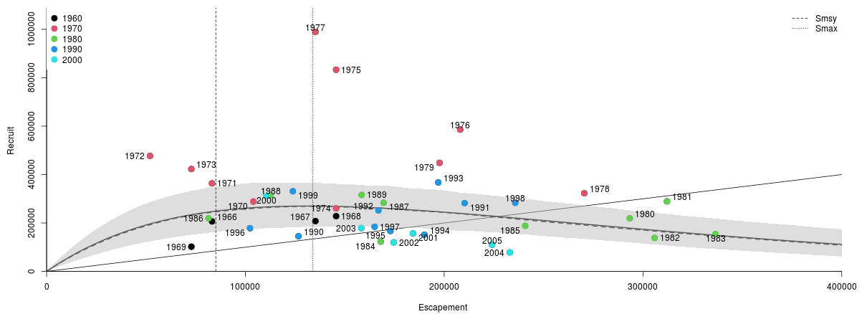

Appendix A1: Spawner Recruit plot for 2012 Bendix/Didson data set with incorrect return info. This is the dataset that set the 2012 Escapement goal.

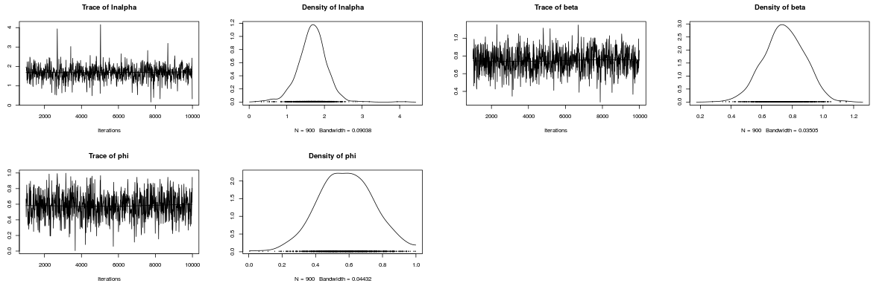

Appendix A2: Trace plots for Bayesian Ricker Spawner Recruit Model.

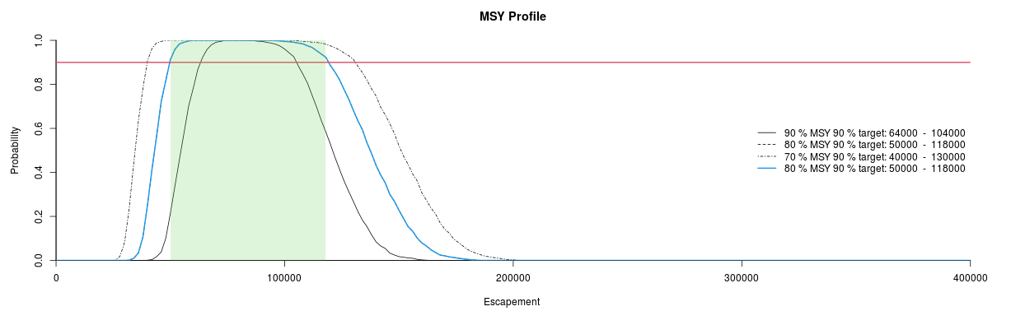

Appendix A3: SMSY Profile, green shaded area represents 80% of SMSY 90% target.

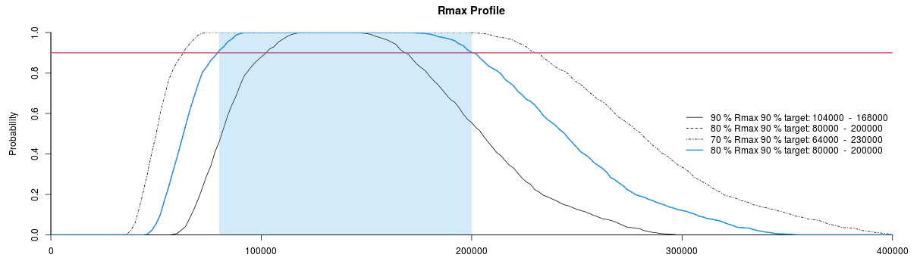

Appendix A4: Rmax Profile, green shaded area represents 80% of Rmax 90% target. 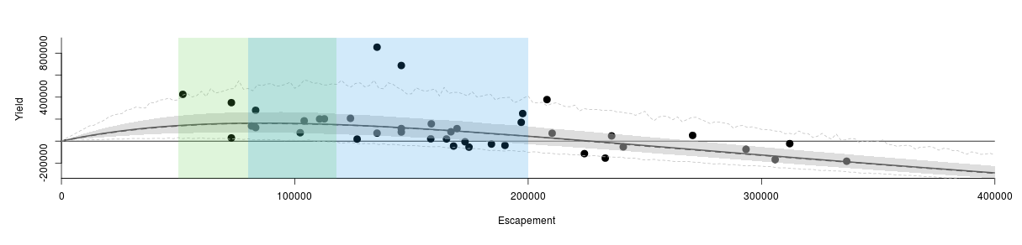

Appendix A5: Yield Profile with SMSY (Green) and Rmax (Blue). Each represents 80% of 90% target.

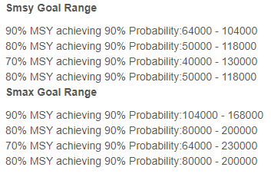

Appendix A6: Dataset from Fair et al. (2012)



**Appendix B. Spawner Recruit Model Results for 2012 Bendix/DIDSON conversion dataset with corrected data errors. (this is the results from the data set that should have been used to generate the 2012 escapement goal)**

* Model Parameters:
  + Ricker Model
  + AR(1) Error
  + Simulations = 10,000
  + Burn-in length = 1,000
  + Thinning = 10
  + Number of Chains = 1
* SMSY = 83,817 *90% CI* (73,170–96,401)
* SMAX =137,924 *90% CI* (109,936–174,929)
* SEQ = 216,001 *90% CI* (185,028–246,715)
* Alpha = 5.047 *90% CI* (3.355–7.253)
* Ln Alpha = 1.593 *90% CI* (1.210–1.981)
* Beta = 0.740 *90% CI* (0.572–0.910)
* Phi = 0.42 *95% CI* (0.040–0.800)

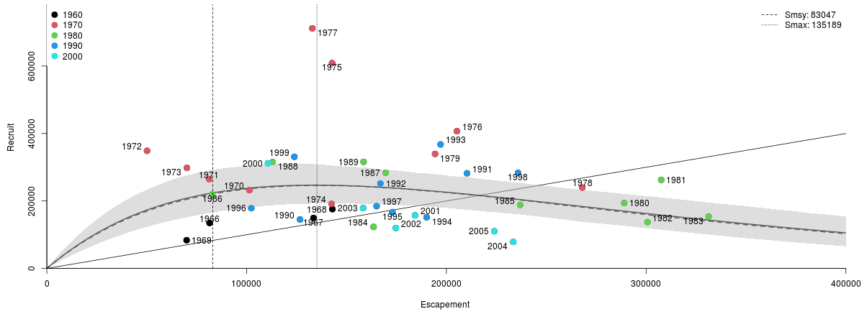

Appendix B1: Spawner Recruit plot for 2012 Bendix/Didson data set with incorrect return info. This is the dataset that set the 2012 Escapement goal.

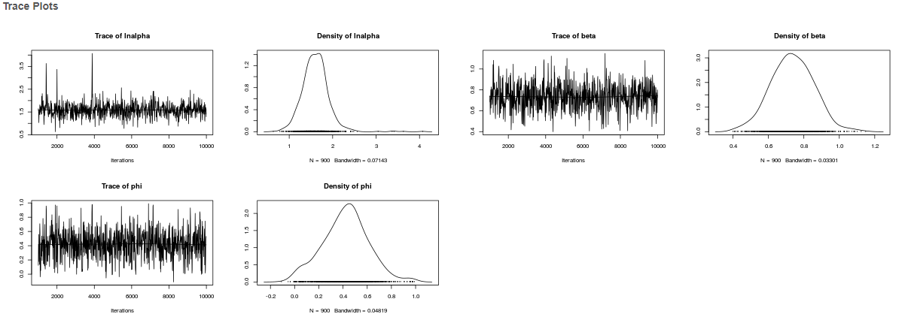

Appendix B2: Trace plots for Bayesian Ricker Spawner Recruit Model.

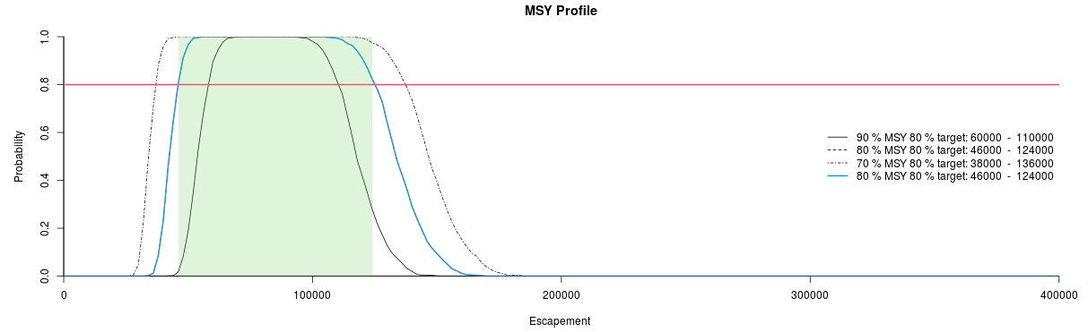

Appendix B3: SMSY Profile, green shaded area represents 80% of SMSY 90% target.

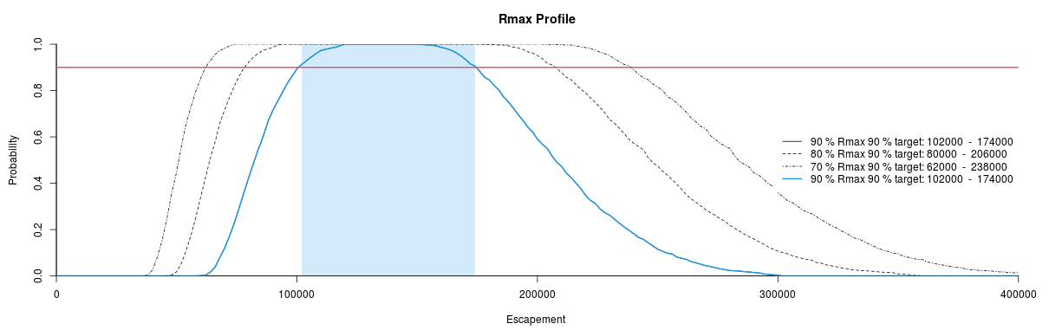

Appendix B4: Rmax Profile, green shaded area represents 80% of Rmax 90% target.

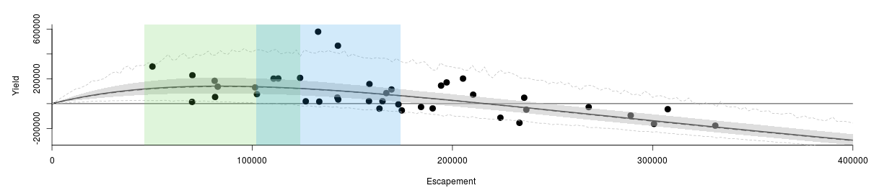

Appendix B5: Yield Profile with SMSY (Green) and Rmax (Blue). Each represents 80% of 90% target.

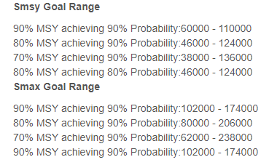

Appendix B6: Dataset from Buck et al. (2012)



**Appendix C. Spawner Recruit Model Results for Bendix/DIDSON conversion dataset updated with most recent 8 years.**

* Model Parameters:
  + Ricker Model
  + AR(1) Error
  + Simulations = 10,000
  + Burn-in length = 1,000
  + Thinning = 10
  + Number of Chains = 1
* SMSY = 82,342 *90% CI* (70,621–95,481)
* SMAX =142,633 *90% CI* (111,980–180,388)
* SEQ = 207,938 *90% CI* (176,033–240,131)
* Alpha = 4.486 *90% CI* (3.169–6.170)
* Ln Alpha = 1.481 *90% CI* (1.153–1.820)
* Beta = 0.716 *90% CI* (0.554–0.893)
* Phi = 0.42 *95% CI* (0.028–0.774)

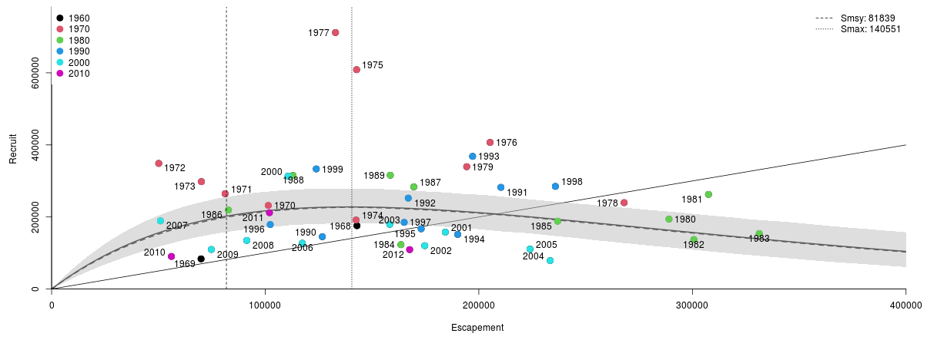

Appendix C1: Spawner Recruit plot for 2012 Bendix/Didson data set with incorrect return info. This is the dataset that set the 2012 Escapement goal.

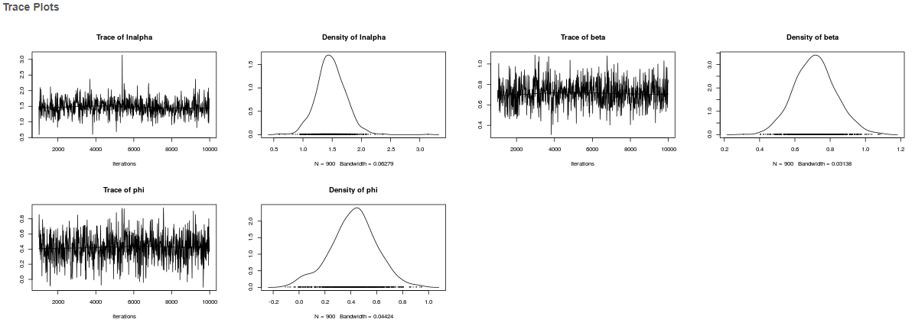

Appendix C2: Trace plots for Bayesian Ricker Spawner Recruit Model.

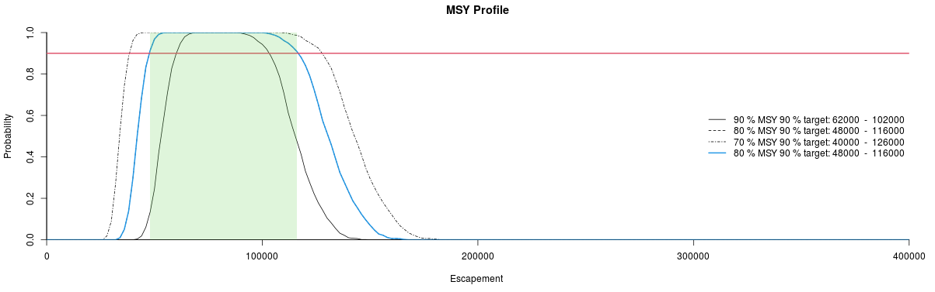

Appendix C3: SMSY Profile, green shaded area represents 80% of SMSY 90% target.

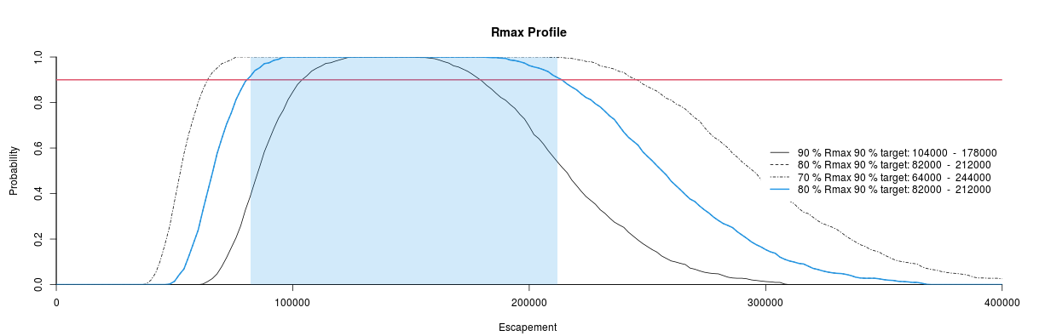

Appendix C4: Rmax Profile, green shaded area represents 80% of Rmax 90% target.

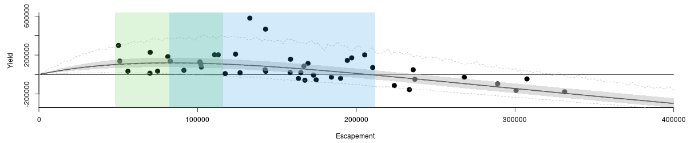

Appendix C5: Yield Profile with SMSY (Green) and Rmax (Blue). Each represents 80% of 90% target.

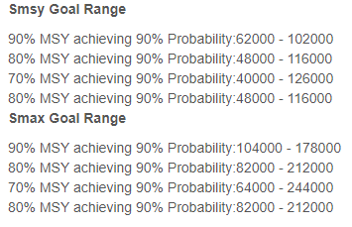

|  |  |  |  |
| --- | --- | --- | --- |
| Appendix C6: Buck et al. (2012) updated through 2020. | | | |
| Brood Year | Spawning Escapement | Total Return | Return per spawner |
| 1968 | 142,951 | 175,766 | 1.23 |
| 1969 | 69,970 | 83,613 | 1.19 |
| 1970 | 101,435 | 231,916 | 2.29 |
| 1971 | 81,237 | 264,749 | 3.26 |
| 1972 | 50,156 | 348,612 | 6.95 |
| 1973 | 70,130 | 297,989 | 4.25 |
| 1974 | 142,535 | 191,584 | 1.34 |
| 1975 | 142,791 | 608,764 | 4.26 |
| 1976 | 205,273 | 406,883 | 1.98 |
| 1977 | 132,907 | 711,779 | 5.36 |
| 1978 | 268,046 | 239,702 | 0.89 |
| 1979 | 194,335 | 339,511 | 1.75 |
| 1980 | 289,040 | 194,006 | 0.67 |
| 1981 | 307,527 | 262,577 | 0.85 |
| 1982 | 300,656 | 137,337 | 0.46 |
| 1983 | 331,270 | 153,903 | 0.46 |
| 1984 | 163,544 | 123,104 | 0.75 |
| 1985 | 236,899 | 188,254 | 0.79 |
| 1986 | 82,777 | 219,175 | 2.65 |
| 1987 | 169,562 | 283,449 | 1.67 |
| 1988 | 113,006 | 315,143 | 2.79 |
| 1989 | 158,551 | 315,785 | 1.99 |
| 1990 | 126,747 | 145,149 | 1.15 |
| 1991 | 210,346 | 282,201 | 1.34 |
| 1992 | 166,965 | 252,253 | 1.51 |
| 1993 | 197,098 | 368,161 | 1.87 |
| 1994 | 190,121 | 151,531 | 0.80 |
| 1995 | 173,014 | 167,131 | 0.97 |
| 1996 | 102,348 | 178,920 | 1.75 |
| 1997 | 165,062 | 185,066 | 1.12 |
| 1998 | 235,845 | 284,847 | 1.21 |
| 1999 | 123,906 | 333,344 | 2.69 |
| Continued. | | | |

|  |  |  |  |
| --- | --- | --- | --- |
| Appendix C6 Continued | |  |  |
| Brood Year | Spawning Escapement | Total Return | Return per spawner |
| 2000 | 110,682 | 313,352 | 2.83 |
| 2001 | 184,317 | 157,782 | 0.86 |
| 2002 | 174,704 | 120,171 | 0.69 |
| 2003 | 158,307 | 179,369 | 1.13 |
| 2004 | 233,475 | 78,789 | 0.34 |
| 2005 | 223,950 | 110,790 | 0.49 |
| 2006 | 117,364 | 127,187 | 1.08 |
| 2007 | 50,960 | 189,016 | 3.71 |
| 2008 | 91,364 | 134,849 | 1.48 |
| 2009 | 74,781 | 109,686 | 1.47 |
| 2010 | 56,092 | 90,383 | 1.61 |
| 2011 | 101,995 | 211,679 | 2.08 |
| 2012 | 167,618 | 109,294 | 0.65 |
| 1968-2012 Average | 159,815 | 230,546 | 1.79 |
| No. of Years | 45 | 45 | 45 |
| a Spawning escapement is defined as the sonar count minus sport and subsistence harvest occurring above the counting sonar (Buck et al. 2012). | | | |

**Appendix D. Spawner Recruit Model Results for Nushagak Chinook salmon Run Reconstruction dataset though 2020.**

* Model Parameters:
  + Ricker Model
  + AR(1) Error
  + Simulations = 10,000
  + Burn-in length = 1,000
  + Thinning = 10
  + Number of Chains = 1
* SMSY = 109,068 *90% CI* (93,114–125,533)
* SMAX =187,669 *90% CI* (151,886–234,079)
* SEQ = 276,102 *90% CI* (231,577–319,337)
* Alpha = 4.536 *90% CI* (3.168–6.257)
* Ln Alpha = 1.491 *90% CI* (1.153–1.834)
* Beta = 0.542 *90% CI* (0.427–0.658)
* Phi = 0.544 *95% CI* (0.209–0.855)

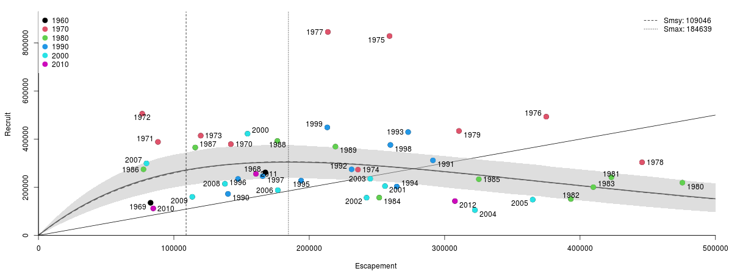

Appendix D1: Spawner Recruit plot for 2012 Bendix/Didson data set with incorrect return info. This is the dataset that set the 2012 Escapement goal.

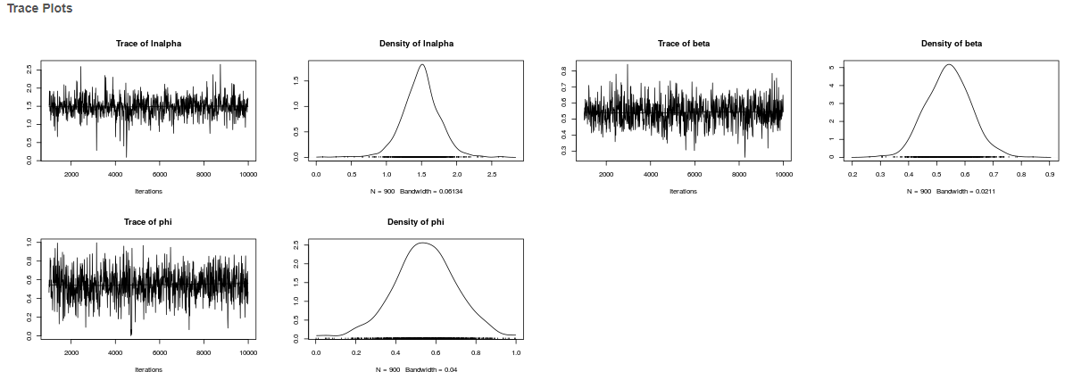

Appendix D2: Trace plots for Bayesian Ricker Spawner Recruit Model.

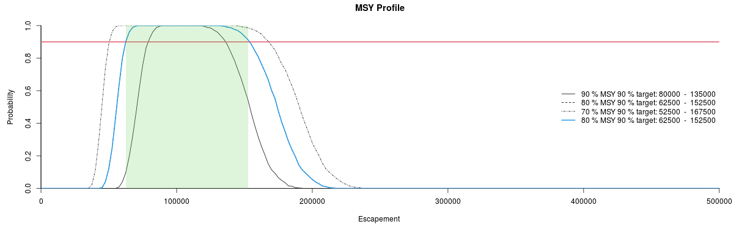

Appendix D3: SMSY Profile, green shaded area represents 80% of SMSY 90% target.

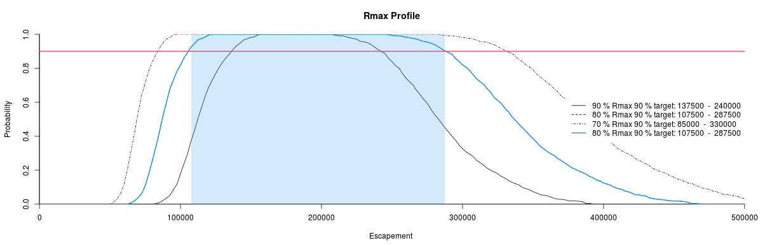

Appendix D4: Rmax Profile, green shaded area represents 80% of Rmax 90% target.

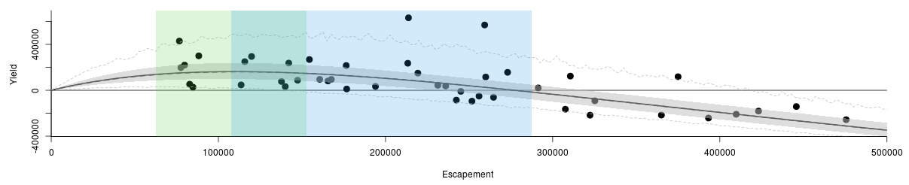

Appendix D5: Yield Profile with SMSY (Green) and Rmax (Blue). Each represents 80% of 90% target.

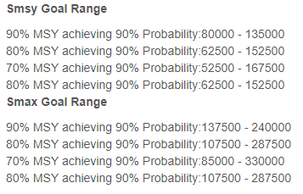

|  |  |  |  |
| --- | --- | --- | --- |
| Appendix D6: Head and Hamazaki (in prep) Nushagak Chinook salmon run reconstruction dataset. | | | |
| Year | Spawning Escapement | Total Return | Return per spawner |
| 1968 | 167,570 | 261,876 | 1.56 |
| 1969 | 82,809 | 135,449 | 1.64 |
| 1970 | 142,080 | 379,022 | 2.67 |
| 1971 | 88,263 | 388,326 | 4.40 |
| 1972 | 76,653 | 505,638 | 6.60 |
| 1973 | 119,850 | 414,356 | 3.46 |
| 1974 | 235,980 | 273,159 | 1.16 |
| 1975 | 259,300 | 828,438 | 3.19 |
| 1976 | 375,010 | 493,173 | 1.32 |
| 1977 | 213,740 | 845,434 | 3.96 |
| 1978 | 445,770 | 303,575 | 0.68 |
| 1979 | 310,560 | 433,921 | 1.40 |
| 1980 | 475,580 | 218,969 | 0.46 |
| 1981 | 423,140 | 241,292 | 0.57 |
| 1982 | 393,210 | 151,205 | 0.38 |
| 1983 | 409,800 | 200,440 | 0.49 |
| 1984 | 251,710 | 156,828 | 0.62 |
| 1985 | 325,250 | 233,383 | 0.72 |
| 1986 | 77,577 | 274,521 | 3.54 |
| 1987 | 115,790 | 365,241 | 3.15 |
| 1988 | 176,470 | 392,258 | 2.22 |
| 1989 | 219,340 | 368,651 | 1.68 |
| 1990 | 140,000 | 172,336 | 1.23 |
| 1991 | 291,360 | 311,669 | 1.07 |
| 1992 | 231,280 | 274,476 | 1.19 |
| 1993 | 273,030 | 429,338 | 1.57 |
| 1994 | 264,610 | 202,904 | 0.77 |
| 1995 | 193,990 | 227,467 | 1.17 |
| 1996 | 147,390 | 234,737 | 1.59 |
| 1997 | 165,560 | 246,244 | 1.49 |
| 1998 | 259,930 | 375,790 | 1.45 |
| 1999 | 213,310 | 448,786 | 2.10 |
| Continued. | | | |

|  |  |  |  |
| --- | --- | --- | --- |
| Appendix D6 Continued | |  |  |
| Year | Spawning Escapement | Total Return | Return per spawner |
| 2000 | 154,440 | 422,478 | 2.74 |
| 2001 | 255,950 | 204,736 | 0.80 |
| 2002 | 242,350 | 156,578 | 0.65 |
| 2003 | 245,050 | 235,308 | 0.96 |
| 2004 | 322,340 | 105,190 | 0.33 |
| 2005 | 365,040 | 148,479 | 0.41 |
| 2006 | 176,770 | 187,958 | 1.06 |
| 2007 | 79,768 | 299,154 | 3.75 |
| 2008 | 137,740 | 214,351 | 1.56 |
| 2009 | 113,610 | 160,183 | 1.41 |
| 2010 | 84,770 | 112,026 | 1.32 |
| 2011 | 160,630 | 255,521 | 1.59 |
| 2012 | 307,600 | 142,527 | 0.46 |
| 1968-2012 Average | 226,933 | 298,520 | 1.70 |
| No. of Years | 45 | 45 | 45 |